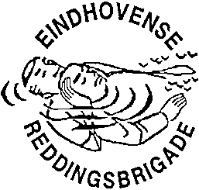
INTERNATIONALE ONTMOETING 2020
INTERNATIONAL MEETING 2020
REDDINGSSPORT / LIFE SAVING SPORT

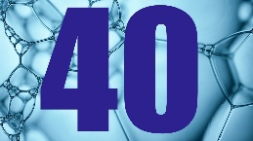
Aanmeldingsformulier Internationale Ontmoeting 2020
Entry form International Meeting 2020

Zenden aan / Send to: e.dekkers7@upcmail.nl
Of per post / or by mail: Bob Dekkers, Tarwelaan 89, 5632 KD Eindhoven

The brigade uit
The lifesaving club from
A: De SERC-wedstrijd met  The Incident Competition (SERC) with |  |  | Seniorenploeg(en) / Senior Team(s) 15+
 |  |  | Juniorenploeg(en) / Junior Team(s) 12-14
B: De wedstrijden zwemmend redden met  The relay competitions with  Age-categories  C: Year of birth 2008-2006  B: Year of birth 2005-2002  A: Year of birth 2004 or earlier (Open class)  M: Year of birth 1990 or earlier (Masters). |  |  | Meisjes/Girls C-team(s)
 |  |  | Jongens/Boys C-team(s)
 |  |  | Dames/Female B-team(s)
 |  |  | Heren/Male B-team(s)
 |  |  | Dames/Female A-team(s)
 |  |  | Heren/Male A-team(s)
 |  |  | Dames/Female M-team(s)
 |  |  | Heren/Male M-team(s)
In het grijze vakje het AANTAL deelnemende teams. In the grey box the NUMBER of teams.

Contactadres / Contactaddress

Naam / Name
Adres / Address
PC + Woonplaats / Postal code and City
Telefoon / Telephone
E-mail

Remarks:

