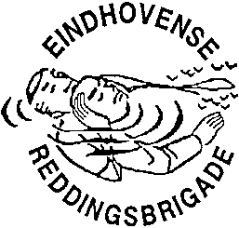
INTERNATIONALE ONTMOETING 2024
INTERNATIONAL MEETING 2024
REDDINGSSPORT / LIFE SAVING SPORT

Aanmeldingsformulier Internationale Ontmoeting 2024
Entry form International Meeting 2024

Zenden aan / Send to: e.dekkers7@upcmail.nl
Of per post / or by mail: Bob Dekkers, Tarwelaan 89, 5632 KD Eindhoven

The brigade uit
The lifesaving club from
A: De SERC-wedstrijd met  The Incident Competition (SERC) with |  |  | Seniorenploeg(en) / Senior Team(s) 15+
 |  |  | Juniorenploeg(en) / Junior Team(s) 12-14
B: De wedstrijden zwemmend redden met  The relay competitions with  Age-categories  C: Year of birth 2012-2010  B: Year of birth 2009-2006  A: Year of birth 2008 or earlier (Open class)  M: Year of birth 1994 or earlier (Masters). |  |  | Meisjes/Girls C-team(s)
 |  |  | Jongens/Boys C-team(s)
 |  |  | Dames/Female B-team(s)
 |  |  | Heren/Male B-team(s)
 |  |  | Dames/Female A-team(s)
 |  |  | Heren/Male A-team(s)
 |  |  | Dames/Female M-team(s)
 |  |  | Heren/Male M-team(s)
In het grijze vakje het AANTAL deelnemende teams. In the grey box the NUMBER of teams.

Contactadres / Contactaddress

Naam / Name
Adres / Address
PC + Woonplaats / Postal code and City
Telefoon / Telephone
E-mail

Remarks:

