INTERNATIONAL MEETING 2020
Lifesaving sport

Eindhoven, November 2019
For more info see our updates on:
www.eindhovensereddingsbrigade.nl

Dear Sportfriends,

In the weekend of 25 and 26 January 2020 the Eindhovense reddingsbrigade organises the 40th international meeting. The whole event will take place in the 50m competition pool of the Pieter van den Hoogenband swim stadium of ‘De Tongelreep’ in Eindhoven.

The incident-competitions (SERC) are from 12.30-16.30h. on Saturday 25 January. A team has four members, female, male or mixed. You can enter Senior teams (15 years and older) and Junior teams (12-14 years). We will run the incident competition according to SERC-principles: 2 preliminary rounds for all teams and a final for Juniors and for Seniors with 8 teams.

The relay-competitions take place on Sunday 26 January from 12.30-17.00 h. Each team has at least four swimmers. You can enter female, male or mixed teams (mixed teams enter in the male classifications).
New: Age-categories
C: Year of birth 2008 – 2006
B: Year of birth 2005 – 2002
A: Year of birth 2004 or earlier (Open class)
M: Year of birth 1990 or earlier (Masters).

We warmly invite you to our international meeting.
On the entry form you can let us know whether you are coming or not and in which competitions you'll enter when you are coming.
For participation in this competition the entry fee is Euro 10,- for each participating team. Please transfer the amount due by bank to us. You will receive bank details after we receive your entry.

We would like to receive your entry for the competitions before the 19th of January 2020 on the following address:
Preferably e-mail: e.dekkers7@upcmail.nl
or Bob Dekkers, Tarwelaan 89, 5632 KD Eindhoven (tel: +31 6 21 23 79 18).

We hope to welcome you in January. With friendly brigade-greetings,

Committee Eindhovense reddingsbrigade

Entering via e-mail: send an e-mail to e.dekkers7@upcmail.nl and we will send you a digital entry form.
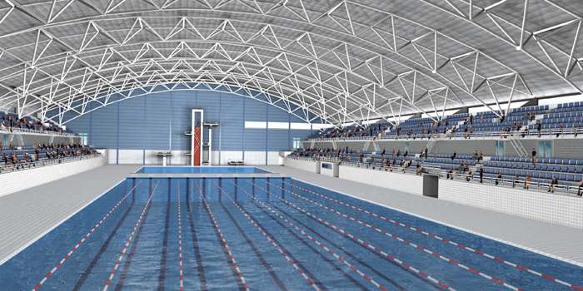
Or see our website for an entry form.
INTERNATIONALE ONTMOETING 2020
REDDINGSSPORT

PROGRAM LIFE SAVING RELAY COMPETITION

1. C-category MANIKIN-DIVING WITH TEAMS (4 persons)
Swimmer 1 starts with a jump (surface before the 5m-line). He swims to the 25m.-line (eyes over the surface). There he dives to an orange manikin and brings it up with him. Immediately after number 1 the swimmers 2, 3 and 4 start. They swim to the 20m.line and wait for number 1. As soon as number 1 is back at the 20m.line (with the manikin) the 4 swimmers swim back to the start side in a family-transporting-grip.
2. A-B-M MANIKIN-DIVING WITH TEAMS (4 persons)
See number 1.
3. C-category 4 x 25m MANIKIN-TRANSPORT
Start in the water, one hand at the manikin, one hand on the poolside. Swimmers 1 and 3 hand over the manikin at the 25m-line sideways, at the exchange from number 2 to 3 swimmer number 2 has to touch the poolside before handing over the manikin.
4. A-B-M 4 x 25m MANIKIN TRANSPORT
See number 3.
5. C-category 4 x 50m SWIMMING-RELAY
1. 50m. backstroke with stick (no use of arms)
2. 50m. freestyle
3. 50m. breaststroke (eyes over the surface)
4. 50m. freestyle with fins
6. A-B-M 4 x 50m LIFE-SAVING-RELAY
1. 50m. freestyle with fins
2. 50m. freestyle
3. 50m. backstroke (no use of arms)
4. 50m. towing (with number 2 as a subject)
7. C-category 4 x 50m RESCUE TUBE RELAY
1. 50m. freestyle
2. 50m. freestyle with fins
3. 50m. freestyle with rescue tube
4. 50m. freestyle with fins; towing no. 3 holding the rescue tube
8. A-B-M 4 x 50m RESCUE TUBE RELAY
See number 7.
9. C-category 4 x 50m LINE-TOW-RELAY with a life harness
Each team-member has to swim one time and has to tow one time. While swimming, the harness has to be over both shoulders. If not, the swimmer has to correct this before swimming on. A swimmer starts and swims to the 25m.-line. There he picks up a stick (handed by a team-member) and he will be towed back. At the start-side the second swimmer puts on the life-harness and does the same as number one, and so on.
10. A-B-M 4 x 50m LINE-TOW-RELAY with a life harness
See number 9.

B-A-M swim mixed according to entry times. There are separate trophies.

