INTERNATIONAL MEETING 2024
Lifesaving sport

Eindhoven, December 2023
For more info see our updates on:
www.eindhovensereddingsbrigade.nl/io

Dear Sportfriends,

In the weekend of 2 and 3 March 2024 the Eindhovense reddingsbrigade organises the 42nd international meeting. The event will take place in the Pieter van den Hoogenband swim stadium of ‘De Tongelreep’ in Eindhoven.

The incident-competitions (SERC) are from 14.30-18.30h. on Saturday 3 March in the 10x50m training pool with limited spectator capacity. A team has four members, female, male or mixed. You can enter Senior teams (15 years and older) and Junior teams (12-14 years). We will run the incident competition according to SERC-principles: 2 preliminary rounds for all teams and a final for Juniors and for Seniors with 8 teams.

The relay-competitions take place on Sunday 3 March from 12.30-17.00 h in the 25x50m competition pool. Each team has at least four swimmers. You can enter female, male or mixed teams (mixed teams enter in the male classifications).
New: Age-categories
C: Year of birth 2012 – 2010
B: Year of birth 2009 – 2006
A: Year of birth 2008 or earlier (Open class)
M: Year of birth 1994 or earlier (Masters).

We warmly invite you to our international meeting.
On the entry form you can let us know whether you are coming or not and in which competitions you'll enter when you are coming.
For participation in this competition the entry fee is Euro 10,- for each participating team. Please transfer the amount due by bank to us. You will receive bank details after we receive your entry.

We would like to receive your entry for the competitions before the 25th of March 2024 on the following address:
Preferably e-mail: e.dekkers7@upcmail.nl
or Bob Dekkers, Tarwelaan 89, 5632 KD Eindhoven (tel: +31 6 21 23 79 18).

We hope to welcome you in March. With friendly brigade-greetings,

Committee Eindhovense reddingsbrigade

Entering via e-mail: send an e-mail to e.dekkers7@upcmail.nl and we will send you a digital entry form.
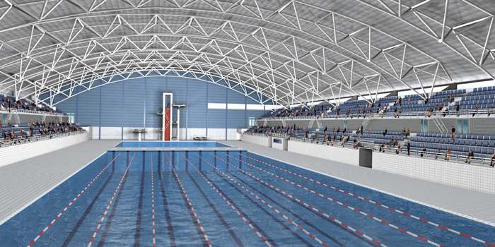
Or see our website for an entry form.
INTERNATIONALE ONTMOETING 2024
REDDINGSSPORT

PROGRAM LIFE SAVING RELAY COMPETITION

1. C-category MANIKIN-DIVING WITH TEAMS (4 persons)
Swimmer 1 starts with a jump (surface before the 5m-line). He swims to the 25m.-line (eyes over the surface). There he dives to an orange manikin and brings it up with him. Immediately after number 1 the swimmers 2, 3 and 4 start. They swim to the 20m.line and wait for number 1. As soon as number 1 is back at the 20m.line (with the manikin) the 4 swimmers swim back to the start side in a family-transporting-grip.
2. A-B-M MANIKIN-DIVING WITH TEAMS (4 persons)
See number 1.
3. C-category 4 x 25m MANIKIN-TRANSPORT
Start in the water, one hand at the manikin, one hand on the poolside. Swimmers 1 and 3 hand over the manikin at the 25m-line sideways, at the exchange from number 2 to 3 swimmer number 2 has to touch the poolside before handing over the manikin.
4. A-B-M 4 x 25m MANIKIN TRANSPORT
See number 3.
5. C-category 4 x 50m SWIMMING-RELAY
1. 50m. backstroke with stick (no use of arms)
2. 50m. freestyle
3. 50m. breaststroke (eyes over the surface)
4. 50m. freestyle with fins
6. A-B-M 4 x 50m LIFE-SAVING-RELAY
1. 50m. freestyle with fins
2. 50m. freestyle
3. 50m. backstroke (no use of arms)
4. 50m. towing (with number 3 as a subject)
7. C-category 4 x 50m RESCUE TUBE RELAY
1. 50m. freestyle
2. 50m. freestyle with fins
3. 50m. freestyle with rescue tube
4. 50m. freestyle with fins; towing no. 3 holding the rescue tube
8. A-B-M 4 x 50m RESCUE TUBE RELAY
See number 7.
9. C-category 4 x 50m LINE-TOW-RELAY with a life harness
Each team-member has to swim one time and has to tow one time. While swimming, the harness has to be over both shoulders. If not, the swimmer has to correct this before swimming on. A swimmer starts and swims to the 25m.-line. There he picks up a stick (handed by a team-member) and he will be towed back. At the start-side the second swimmer puts on the life-harness and does the same as number one, and so on.
10. A-B-M 4 x 50m LINE-TOW-RELAY with a life harness
See number 9.

B-A-M swim mixed according to entry times. There are separate trophies.

